Development on Hydroshare using VirtualBox and Vagrant

David Valentine, Sept, 2013

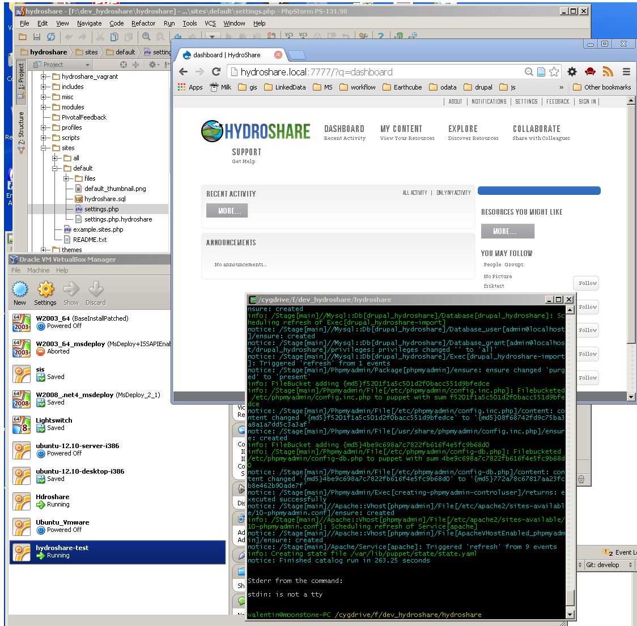

Contents

Goal 3

Overview 3

Installation 3

Tools 3

Requirements 3

Optional 3

Prepare 4

Git Hydroshare Code 4

Notes for Windows Development 4

Local Configuration 4

Set DNS Aliases 4

Configure initial Drupal settings 4

Development using Virtual Machine 5

Start virtual machines 5

Using JetBrains PhPStorm 5

Command Line 6

Seeing the websites 7

Start Development 8

Troubleshooting 9

Committing Code 9

ToDos 9

Notes 9

Other tools to build virtual machines 9

# Goal

Simplify development by removing the requirement that developers install/build a LAMP/WAMP/MAMP stack for hydroshare development. One command configures and builds a virtual machine.

# Overview

Using a virtual box, allows a developer to utilize a development environment that is not clutter by a developers workstation. Depending on the configuration, a developer might be able to use familiary tools in their workstation (aka windows text editors), while the code is hosted in an unfamiliar operating system (linux) .

Using a tool called Vagrant allows for a common configuration for a virtual machine for many developers to utilize. The vagrant tool might also be used to publish to a hosted service (aka amazon, digital ocean)

For hydrosphere the vagrant file is configured to use a SHARED directory. This means that a linux virtual machine runs the PhP code, and hosts the database, while the hydroshare code is still on the developers local machine. A developer can utilize an IDE like JetBrains PhpStorm, make changes, and see those changes on the virtual environment.

The boxes are configured to use a proxy port, 7777 is port 80 on the virtual machine, and a phpmyadmin site is also installed to allow for easy viewing of the data in the database.

* <http://hydroshare.local:7777/>
* http://phpmyadmin:7777/

# Installation

## Tools

Install the required software outlined below

### Requirements

#### Git <http://git-scm.com/>

##### Easiest to install using one of the helpers

#### Virtualbox <https://www.virtualbox.org/>

##### VirtualBox platform packages,

##### the Oracle VM VirtualBox Extension Pack.

#### Vagrant http://downloads.vagrantup.com/

### Optional

#### IDE

##### Jetbrains PhpStorm <http://www.jetbrains.com/phpstorm/>

#### Git Helpers

##### TortoiseGit (windows) <https://code.google.com/p/tortoisegit/>

##### SourceTree (Mac, Windows) <https://www.atlassian.com/software/sourcetree/overview>

#### Text editor

##### Notepad++ (windows) <http://notepad-plus-plus.org/>

# Prepare

## Git Hydroshare Code

Hydroshare project is at: <https://github.com/hydroshare>

The repository is: <https://github.com/hydroshare/hydroshare.git>

### Notes for Windows Development

If you are working with a Windows host, you want the shared directory to use Unix line endings.

Do that by configuring this git repository as follows::

$ git config core.eol lf

$ git config core.autocrlf input

You will probably also need to `git reset --hard` to re-extract all files with appropriate line endings.

Do this *before* proceeding with bootstrapping.

## Local Configuration

### Set DNS Aliases

Add to the add to hosts file.

127.0.0.1 hydroshare.local phpmyadmin

Windows: {windows}/system32/drivers/etc/hosts

Linux/Mac: /etc/hosts

### Configure initial Drupal settings

Copy: sites/default/settings.php.hydroshare to sites/default/settings.php

cp sites/default/settings.php.hydroshare sites/default/settings.php

# Development using Virtual Machine

There are two steps, 1) starting the virtual machine, 2) checking that it installed correctly, and then 3) development.

## Start virtual machines

### Using JetBrains PhPStorm

Open directory

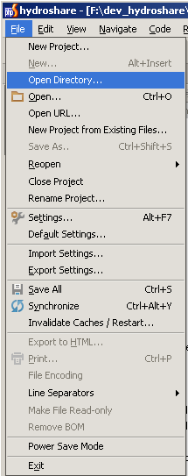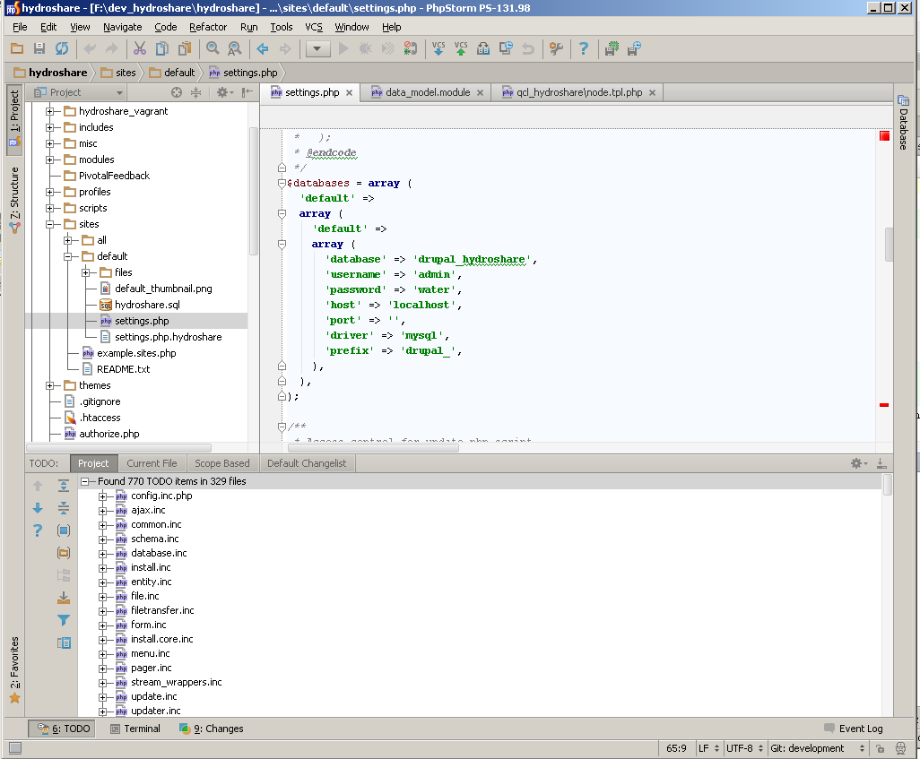

Figure 1. Open Directory Menu, and opened project

Tools>vagrant

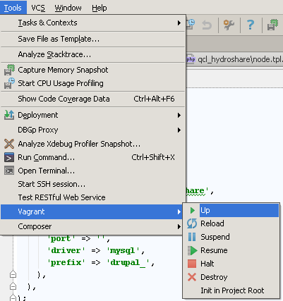

Figure 2. Vagrant Up Menu

Vagrant Terminal Window

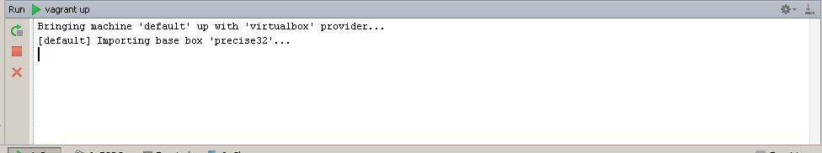

Figure 3. Vagrant Up Starting

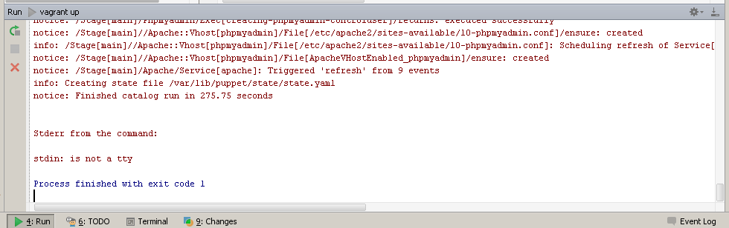

Figure 4. VagrantUp completed

### Command Line

Start a virtual machine in vagrant

$ vagrant up

after a set of changes you will see:

Stderr from the command:

stdin: is not a tty

Process finished with exit code 1

Then the machine is ready, and you should see **hydroshare-test**  in you virtual box admin console.

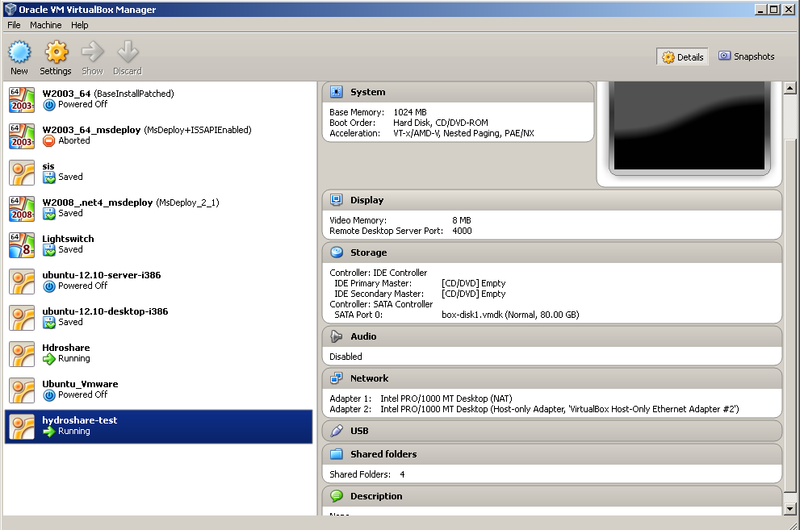

Figure . VIrutal Box Administrative Console (windows)

Afterwards you may access the box by a terminal with

$ vagrant ssh

## Seeing the websites

Configured proxy to run on 7777

http://hydroshare.local:7777/

<http://phpmyadmin:7777/>

Go To: <http://hydroshare.local:7777/>

You should see:

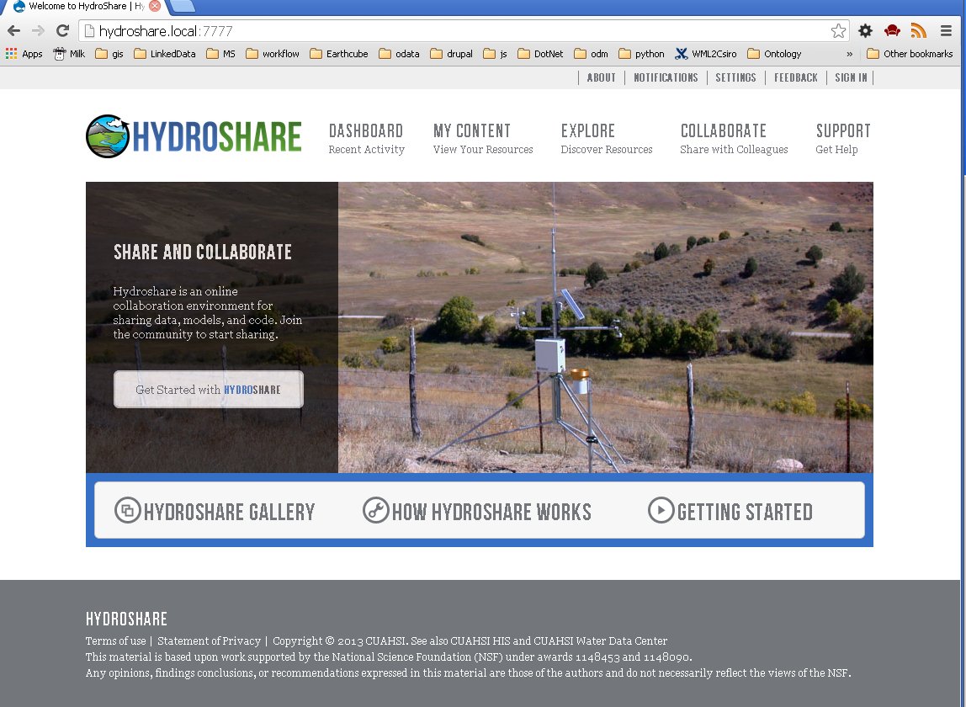

if you see:

C:\Users\valentin\Dropbox\DruaplInstall.tiff

You have not copied over settings file, and drupal is installing a complete new instance (this is being worked on).

cp sites/default/settings.php.hydroshare sites/default/settings.php

## Start Development

The root of the hydroshare that you cloned in git is shared as /hydroshare on the virtual machine. Simply, any changes you do on the local directory will be reflected on the virtual machine at http://hydroshare.local:7777/

So, start developing.

# Troubleshooting

Vagrant up says:

Stderr from the command:

stdin: is not a tty

Process finished with exit code 1

Ignore

I am asked to install drupal:

You have not copied over settings file, and drupal is installing a complete new instance (this is being worked on).

cp sites/default/settings.php.hydroshare sites/default/settings.php

# Committing Code

TBD

# ToDos

* Presently this is a fully pre-configured instance. Ideally this should be a clean Hydroshare profile.
  + Started one at profiles/hydroshare
    - Module with all the dependencies is sites/all/modules/hydroshare/hydroshare_tweaks (see as a practice in the scratchpads.eu drupal profile).
  + profile needs to have start data. Can be done using drush, or a set of curl scrips.

# Notes

## Other tools to build virtual machines

linux:

* https://puphpet.com/

** used for this project

* http://rove.io/

windows:

* http://seletz.github.io/blog/2012/01/17/creating-vagrant-base-boxes-with-veewee/

* https://github.com/WinRb/vagrant-windows